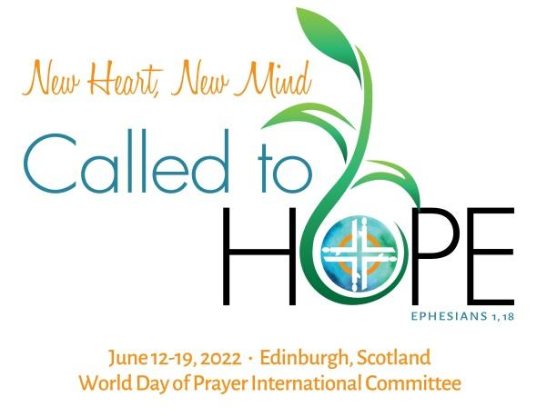
Issue: May 2020

Invitation to World Day of Prayer International Committee Meeting
Logo / Date / Purpose / Theme / Donate

Click view this email in your browser. Click Translate for language options.
Haga clic en view this email in your browser. Haga clic en Translate para opciones de idioma.
Cliquez sur view this email in your browser. Cliquez sur Translate pour les options de langue.

Dear sisters,
On behalf of WDPIC, we invite you to the International Committee Meeting that will be hosted by the WDP Scottish Committee in 2022. They are actively preparing to welcome us to their homeland. Thank you, sisters!
We live in unprecedented times and are all working together to slow down the transmission of the Coronavirus (COVID-19) in our communities. We may have unanswered questions at this time and discomforting prospects for the future, but our trust is in God’s goodness. Let us, therefore, “Rise, Take Our Mat and Walk”.
In 1968, the World Day of Prayer International Committee was formed. We left the last International Meeting, held in Foz do Iguaçu, Brazil, in 2017, knowing that we would meet again for the 14th time in 2022. With this Newsletter we are inviting you to envision together this next gathering.
At the top of the Newsletter, you see the logo for the Meeting, which was a collaborative effort with the Presbyterian Women (PC-USA). The leaf of hope, which encircles WDP, springs out in a dancing movement towards a new heart and mind. With the uplifting message about the intention of the gathering, comes the announcement of the date and location of the International Meeting.
Click here to let us know how the 2022 International Meeting logo speaks to you.
SAVE THE DATE: JUNE 12-19, 2022
LOCATION: EDINBURGH, SCOTLAND
REGISTRATION AND ACCOMMODATION FEES WILL BE ANNOUNCED SOON
The purpose of the World Day of Prayer International Committee Meeting
The World Day of Prayer International Committee is composed by the WDP National Committees elected delegates, who come together to share experiences and grow in understanding of one another. They also select themes and writers for WDP services, elect an ecumenical Executive Committee, define objectives and responsibilities for financing, and consider ways by which the movement may grow.
Click here to send us your questions about the 2022 International Meeting.
“New Heart, New Mind, Called to Hope”
Based on the letter to Ephesians (1,18), we are called to hope; therefore,
We invite you to experience the meeting with a spirit of openness and tolerance, and for that, the heart must be ready: New Heart!
We invite you to discern together the challenges of our time and make wise, visionary and courageous decisions: New Mind!
Above all, we want to reaffirm that the women of World Day of Prayer are carriers and givers of hope: Called to Hope!
Will you join us on the path of “New Heart, New Mind. Called to Hope”?
Click here to share your thoughts about the 2022 International Meeting theme.
Laurence Gangloff
WDPIC Chairperson

Share this newsletter with your WDP Committee!

